CONSTRUCTION COLLECTIVE SAFETY MEASURES (CSM) CHECKLIST
Users: School, student and company  Why: For the safety of the student  When: Before and during WBL  How: The school/teacher sign the checklist before WBL  The student and company/ mentor sign the checklist every day at WBL | SHOOL/BUILDING SITE:  DATE:  SIGNATURE:
PPE | PICTURE | MANDATORY  YES/NO | COMMENT
FACADE NETS | 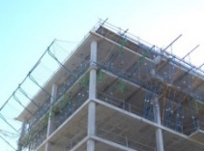
BANISTERS | 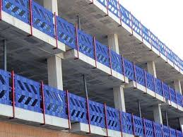
SCAFFOLDS | 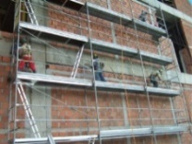

PPE | PICTURE | MANDATORY  YES/NO | COMMENT
HOLES PROTECTION | 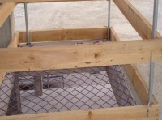
LIFELINE, ANCHORAGE | 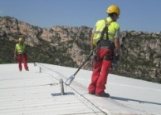
PROTECTION FOR OVERHEAD LINES | 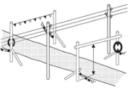
SHORING | 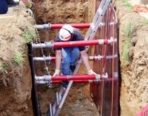

PPE | PICTURE | MANDATORY  YES/NO | COMMENT
MARCHES | 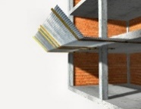
MACHINE PROTECTIONS | 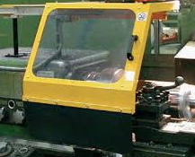
SMOKE EXTRACTION | 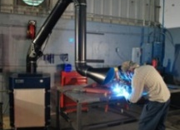
ESCAPE ROUTES | 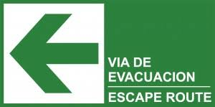
MEETING POINT | 