WELDING-METALWORK PPE CHECKLIST
Users: Students/apprentices in welding and metal work, school and company  Why: For the safety of the student  When: Before and during WBL  How: The school/teacher sign the checklist before WBL  The student and company/ mentor sign the checklist every day at WBL |  |  |  |  |  | SHOOL/BUILDING SITE:  DATE:  SIGNATURE:
PPE | PICTURE | MANDATORY YES/NO | SCHOOL | EMPLOYER | HOST COMPANY |  | STUDENT/  APPRENTICE | COMMENT
SAFETY SHOES | 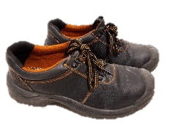
FLAME RETARDANT PANTS
FLAME RETARDANT VEST | 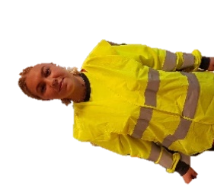
WELDING JACKET
WELDING APRON | 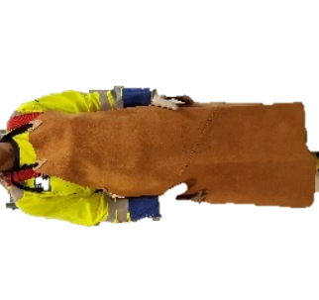
WELDING CUFFS | 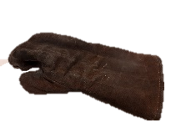
WELDING CLOTHING | 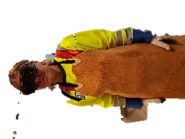
WELDING MASK | 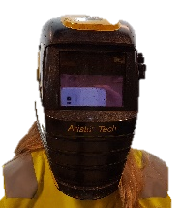
WELDING HOOD | 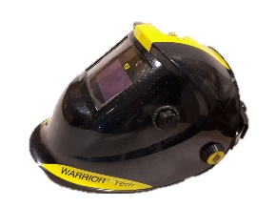
EAR PLUGS
HELMET | 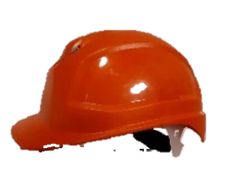
PROTECTIVE GLASSES | 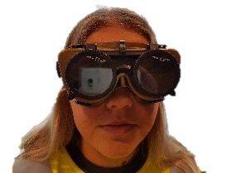
HEAT RESTISTANT

