CONSTRUCTION PPE CHECKLIST
Users: Students/apprentices in construction, school and company  Why: For the safety of the student  When: Before and during WBL  How: The school/teacher sign the checklist before WBL  The student and company/ mentor sign the checklist every day at WBL | SHOOL/BUILDING SITE:  DATE:  SIGNATURE:
 | PPE | PICTURE | MANDATORY YES/NO | SCHOOL | EMPLOYER | HOST  COMPANY | STUDENT/  APPRENTICE | COMMENT
 | SAFETY SHOES | 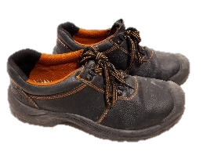
 | HELMET | 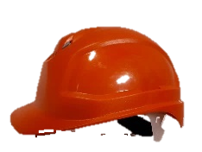
 | GLASSES | 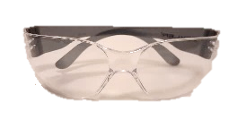
 | GLOVES
 | EAR PLUGS | 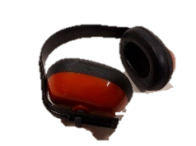
 | VEST | 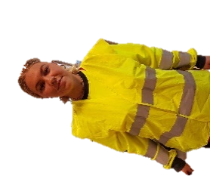
 | HARNESS | 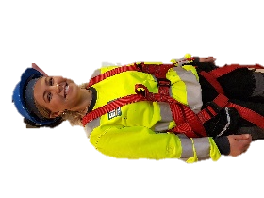
 | OVERALLS | 